Vicon RO-XL VN207 | Sovereign Sulphur | 24m

Tray Test Details
Machine |  | Vicon RO-XL VN207 (VN2070302347) |  |  |  |  |  |  |  |  |  | Spread Width |  |  |  | 24m
Product |  | Sovereign Sulphur |  |  |  |  |  |  |  |  |  | Rate Setting |  |  |  | Setting 29
NSTS Certificate |  | 321364 |  |  |  |  |  |  |  |  |  | Date Tested |  |  |  | 20/01/2023
Test Conditions
Forward Speed | 14 km/h |  |  |  |  |  |  | Ground Condition |  |  |  |  | Grass
Wind Speed | 4 km/h |  |  |  |  |  |  | Wind Direction |  |  |  |  | From behind machine
Product Details - Sovereign Sulphur
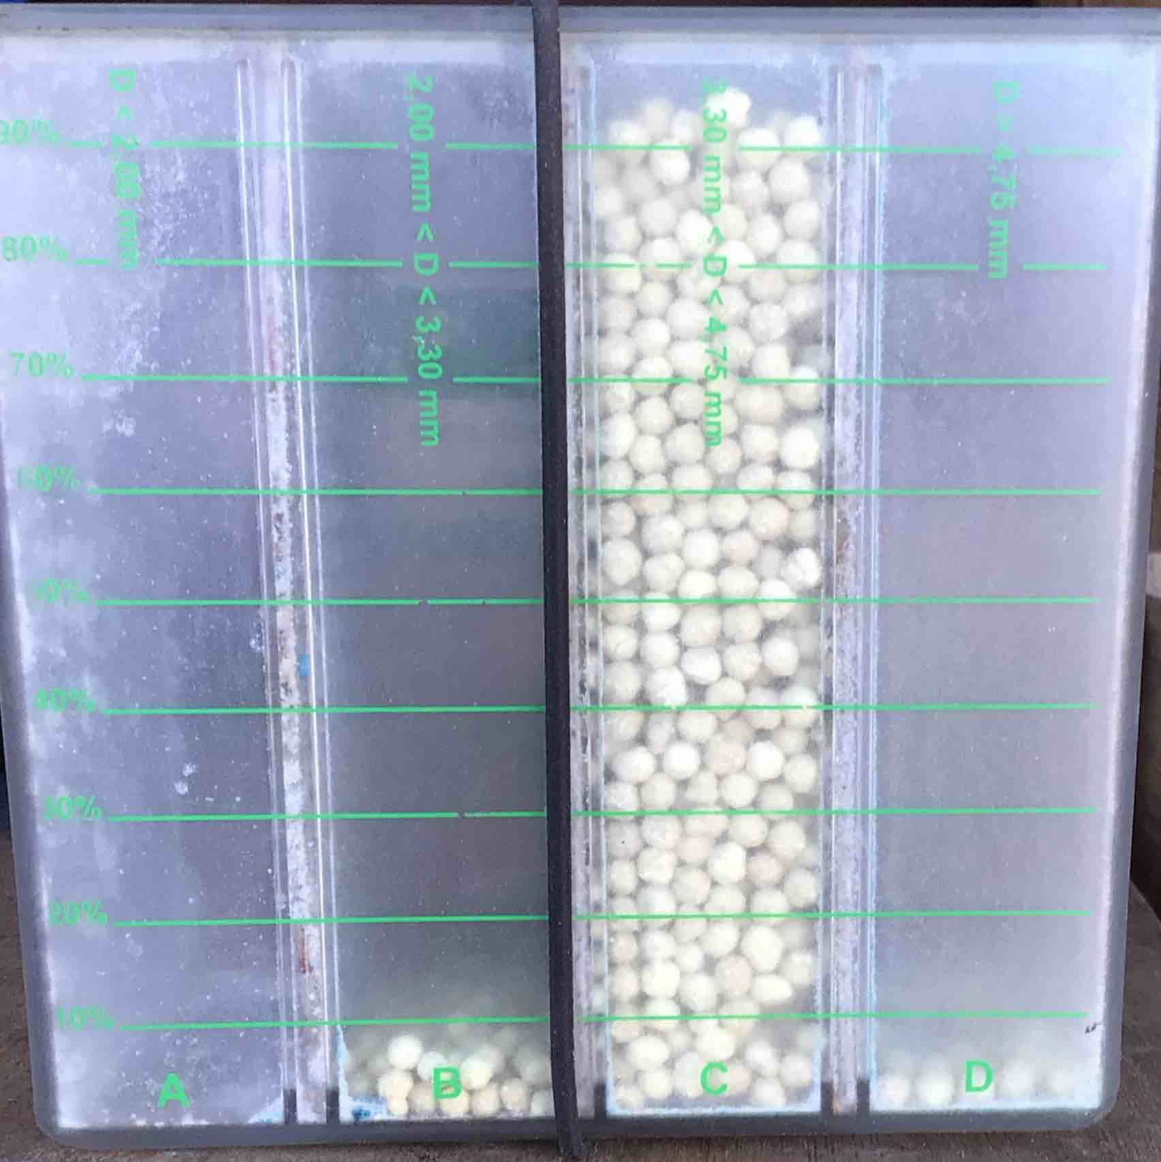 |  |  |  | Batch No. |  |  |  |  |  |  |  |  | 23/08/2022 09:23
 |  |  |  | Product Spread Before Today's Test |  |  |  |  |  |  |  |  | No
 |  |  |  | Lumping In Bag |  |  |  |  |  |  |  |  | No
 |  |  |  | Density (kg/L) |  |  |  |  |  |  |  |  | 1.11
 |  |  |  | Product strength (kg/Force)
 |  |  |  | 6.5 | 7 | 6.5 |  |  |  | 6 | 5 |  | 4.5 |  | 5.5 |  | 6.5 |  | 7.5 | 4.5
 |  |  |  | Average Strength (kg/Force) |  |  |  |  |  |  |  |  | 5.95
 |  |  |  | Grader Box
 |  |  |  | 0 - 2mm |  |  | 2 - 3.3mm |  |  |  |  |  | 3.3 - 4.75mm |  |  |  |  | > 4.75mm
 |  |  |  | 0% |  |  | 5% |  |  |  |  |  | 95% |  |  |  |  | 0%
Successful Run
Disc/Vane/Type |  |  | 285/285/285 |  |  |  |  |  | Spread Setting |  |  |  |  | P
PTO/Disc Speed |  |  | PTO RPM 525 |  |  |  |  |  | Rate Setting |  |  |  |  | Setting 29
Tilt |  |  | 0 |  |  |  |  |  | Headland Setting |  |  |  |  | N/A
Spreader Height |  |  | 75cm from side of disc
Visible Segregation |  |  | No |  |  |  |  |  | Residue on Discs |  |  |  |  | No
Measurable Overlap |  |  | 5m |  |  |  |  |  | Coefficient of Variation |  |  |  |  | 9.34%
Comments: Final spread pattern successful.
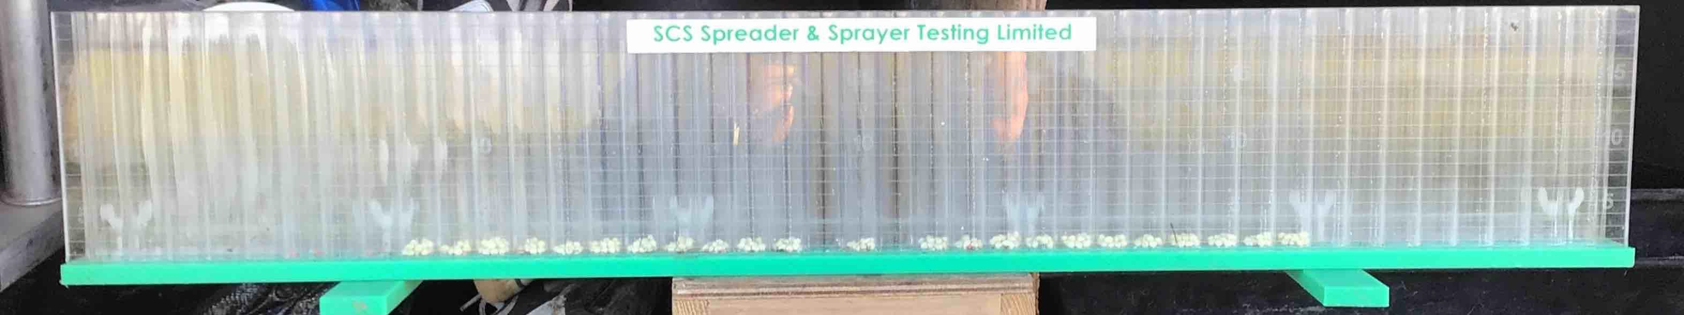
12m 0m 12m

Coefficient of Variation measures the accuracy of the spread pattern. For fertilisers a CV of 15% (as recommended in EB13739-2) should be attained in field conditions. <10% Excellent, 10%-15% Good, 15%-20% Poor, >20% Unacceptable.

There is no CV Pass/Fail for NSTS requirements.

